First & Foremost

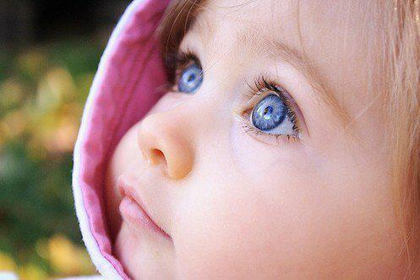

Baby and Child Lifesaving Session
Accidents in the home are still the main cause of injury to our babies and children some more serious than others – but in all cases very distressing and at times life threatening.
This 90 minute session is a must for the whole family including grandparents and possible babysitters so they are informed to make the choices that won’t harm your children. Within 90 minutes you will:

- Assist you to identify danger zones in your own home
- Recognise and change behaviour that leads to serious accidents
- Give you knowledge to make changes before it’s too late
- Give you the skills to make a difference
- How to perform CPR and breathing for your baby and small children
- How to prevent choking and how to deal with a choke should it happen

Come join me for a fun, informal session, meet new people and make those changes.

Carole Hewison Ltd 07889182031 Carolehewisonltd@gmail.com

VENUE
DATE
TIME

